MINI SOC DASHBOARD

TABLE OF CONTENTS
- Abstract
- Introduction
- Company Profile
- Literature Review
- Methodology
- Implementation
- Results and Findings
- Challenges Faced
- Conclusion
- References
- Appendices

ABSTRACT
This project presents a Mini Security Operations Center (Mini SOC) developed using Python. The system analyzes authentication logs, detects suspicious login activities, performs network scanning using Nmap, and generates security reports. A simple dashboard is also created to display network security information. The project demonstrates basic concepts of cyber defence and security monitoring using open-source tools and Python scripting.

INTRODUCTION
Cyber attacks and unauthorized access attempts are increasing rapidly. Organizations use Security Operations Centers (SOC) to monitor and protect their systems. A SOC continuously collects logs, analyzes activities, identifies threats, and generates alerts.
The objective of this project is to develop a Mini SOC Dashboard capable of:
- Monitoring authentication logs
- Detecting suspicious login attempts
- Scanning network ports
- Assessing risk levels
- Generating security reports
- Displaying results through a dashboard
The project is implemented using Python, Nmap, HTML, and basic cybersecurity concepts.

COMPANY PROFILE

Academy of Tech Masters
Academy of Tech Masters is a training and internship organization that provides practical knowledge in various technology domains. The organization offers industry-oriented training programs in Cyber Defence, Artificial Intelligence, Data Science, Web Development, Cloud Computing, and other emerging technologies.
During the internship, students gain hands-on experience through real-world projects and practical implementation.

Internship Details
Student Name: Akella Hasitha
College: Andhra Loyola Institute of Engineering and Technology
Department: Computer Science and Engineering
Internship Domain: Cyber Defence
Internship Duration: 45 Days

LITERATURE REVIEW
Security monitoring plays an important role in protecting computer systems from cyber threats.
Traditional SOC systems collect logs from multiple devices and analyze them for suspicious activities. Log analysis helps identify brute-force attacks, unauthorized access attempts, and abnormal user behavior.
Network scanning tools such as Nmap are widely used to discover active hosts, identify open ports, and detect running services.
Modern SOC platforms combine:
- Log Monitoring
- Threat Detection
- Network Analysis
- Alert Generation
- Dashboard Visualization
This project implements these concepts on a small scale using Python scripts.

METHODOLOGY
The project follows the following workflow:
- Authentication logs are collected.
- Python scripts analyze login attempts.
- Suspicious activities are identified.
- Nmap scans the target network.
- Open ports and services are detected.
- Risk level is calculated.
- Reports are generated.
- Results are displayed on a dashboard.

Modules Used
- Log Analyzer
- Network Analyzer
- Dashboard Generator
- Final Report Generator

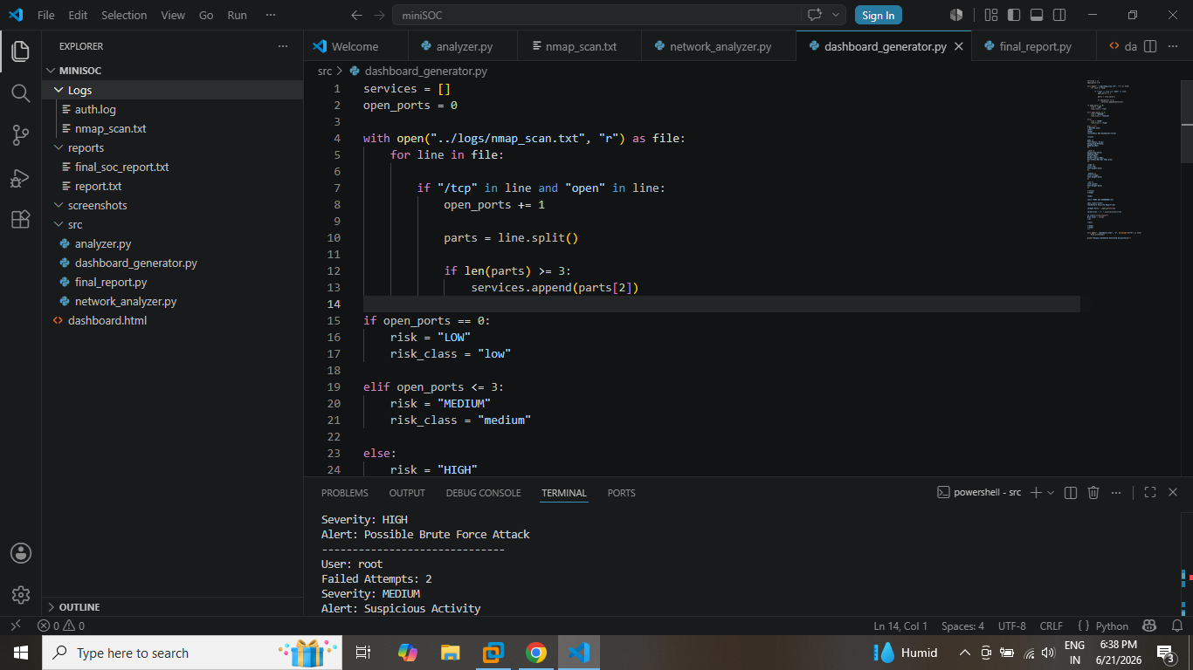

IMPLEMENTATION

1. Log Analysis Module
The authentication log file contains successful and failed login attempts.
Sample entries:
- Login Success user1
- Login Success user2
- Failed Login admin
- Failed Login root
The analyzer script counts failed login attempts and generates threat reports.

Output
User: admin
Failed Attempts: 3
Severity: HIGH
Alert: Possible Brute Force Attack
User: root
Failed Attempts: 2
Severity: MEDIUM
Alert: Suspicious Activity
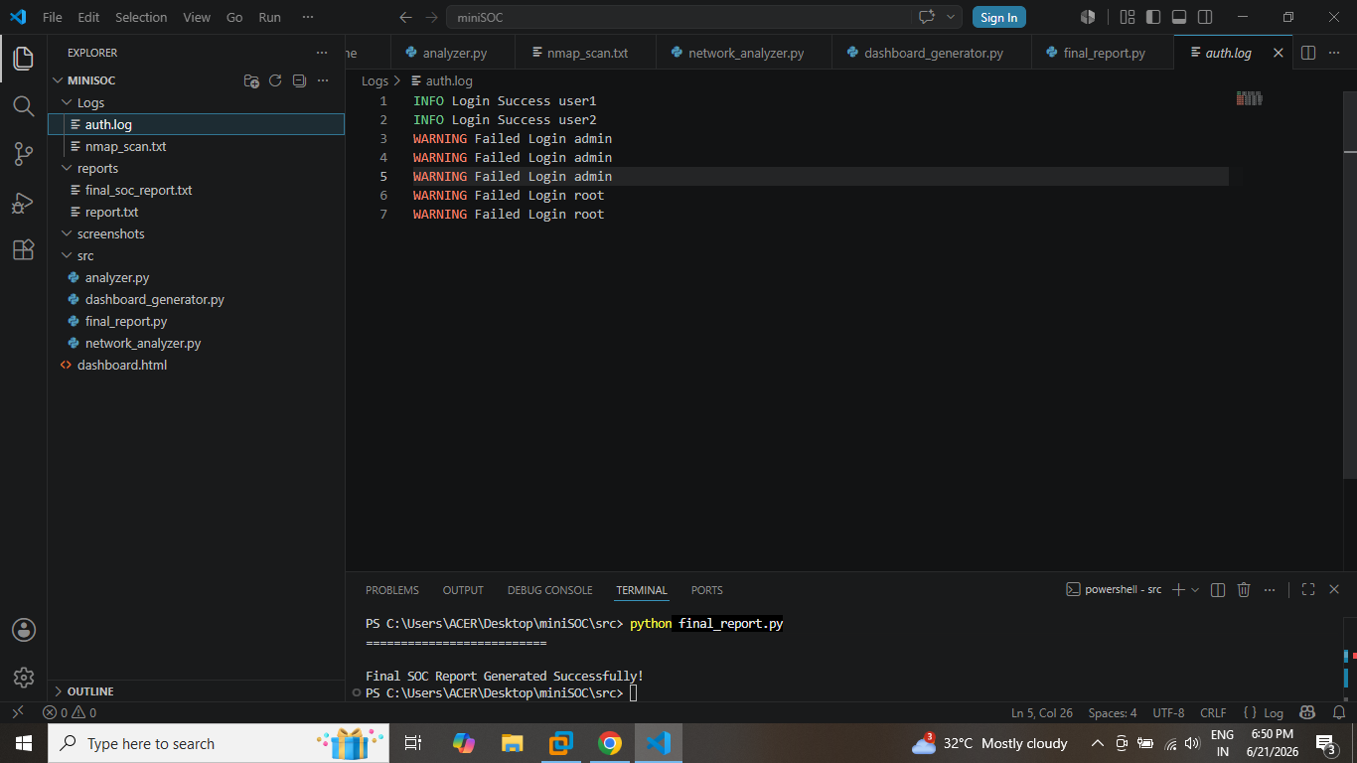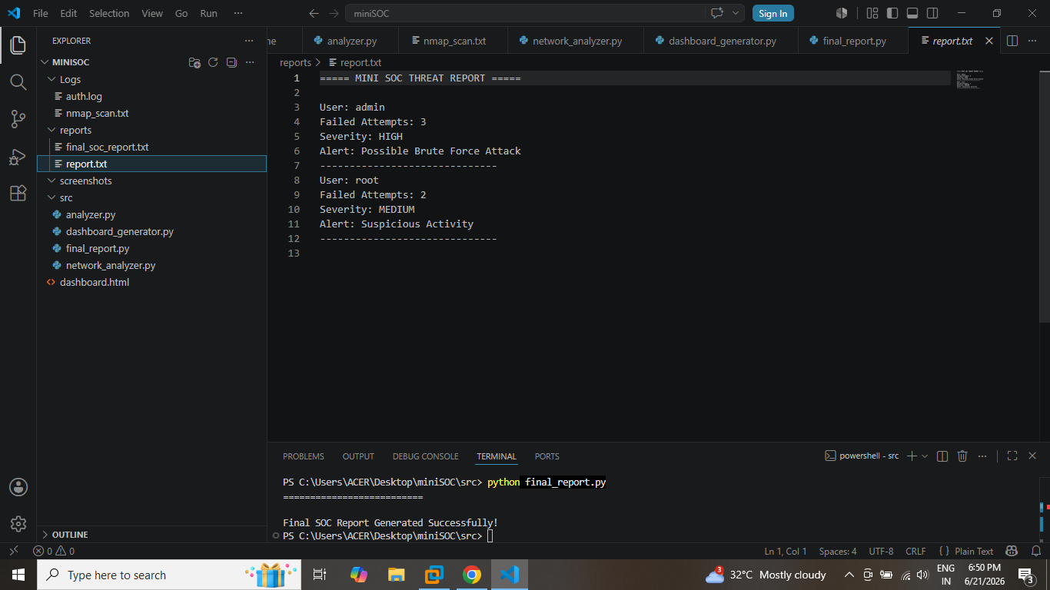

2. Network Analysis Module
Nmap is used to scan the target host.
Command Used:
nmap -Pn -F scanme.nmap.org
Detected Ports:
22/tcp – SSH
80/tcp – HTTP
Filtered Ports:
25/tcp – SMTP
514/tcp – SHELL
Risk Level Generated:
MEDIUM
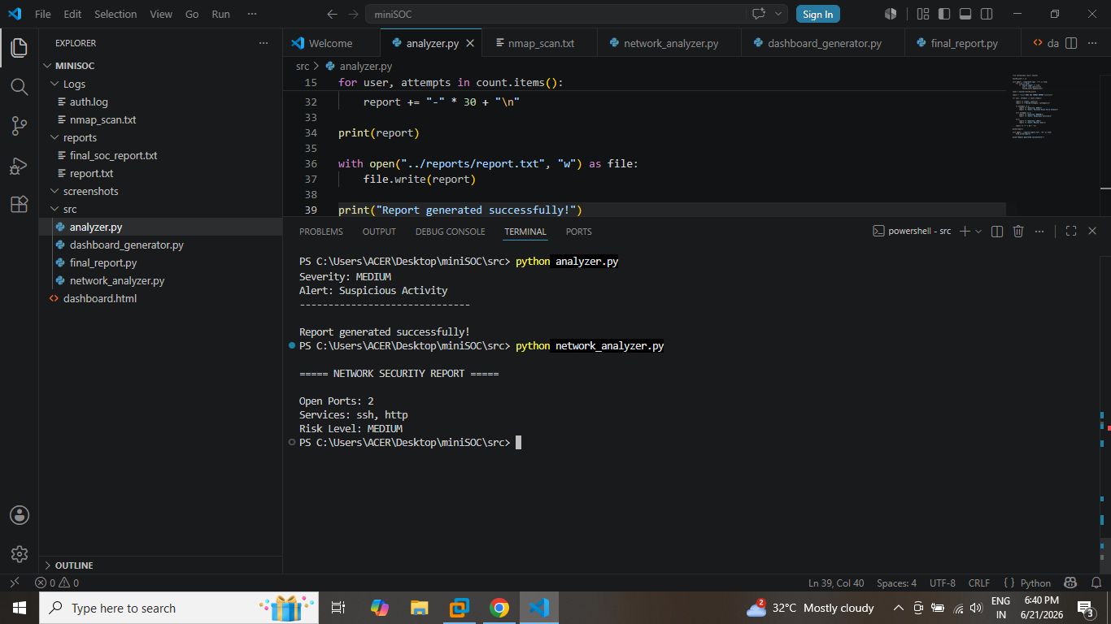

3. Dashboard Generation Module
The dashboard generator script reads scan results and automatically creates an HTML dashboard.
Dashboard Information:
Open Ports: 2
Services: ssh, http
Risk Level: MEDIUM
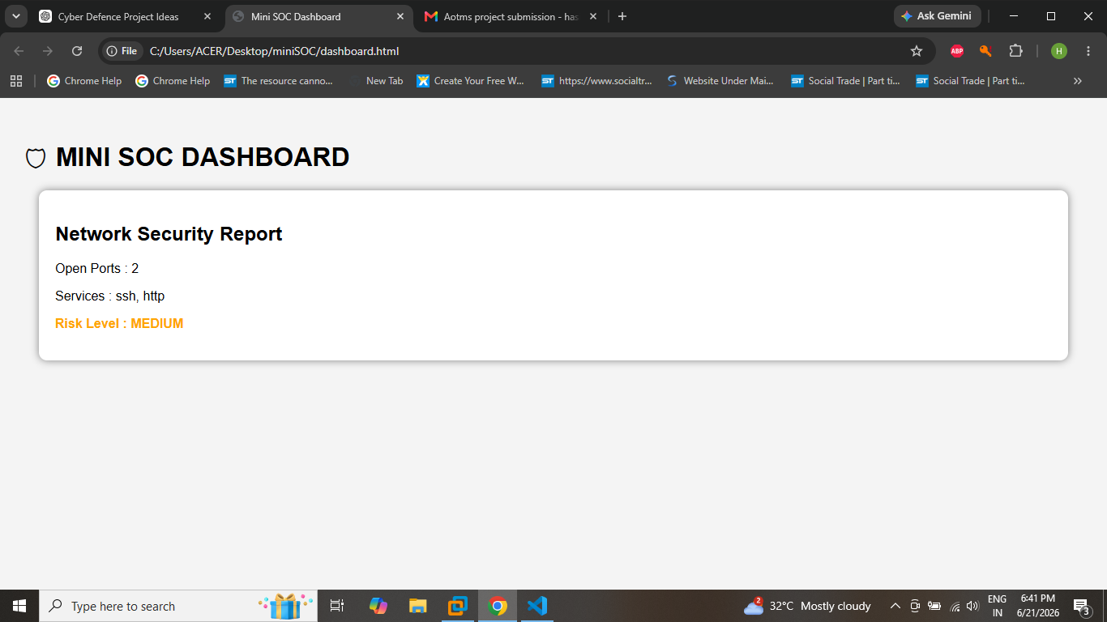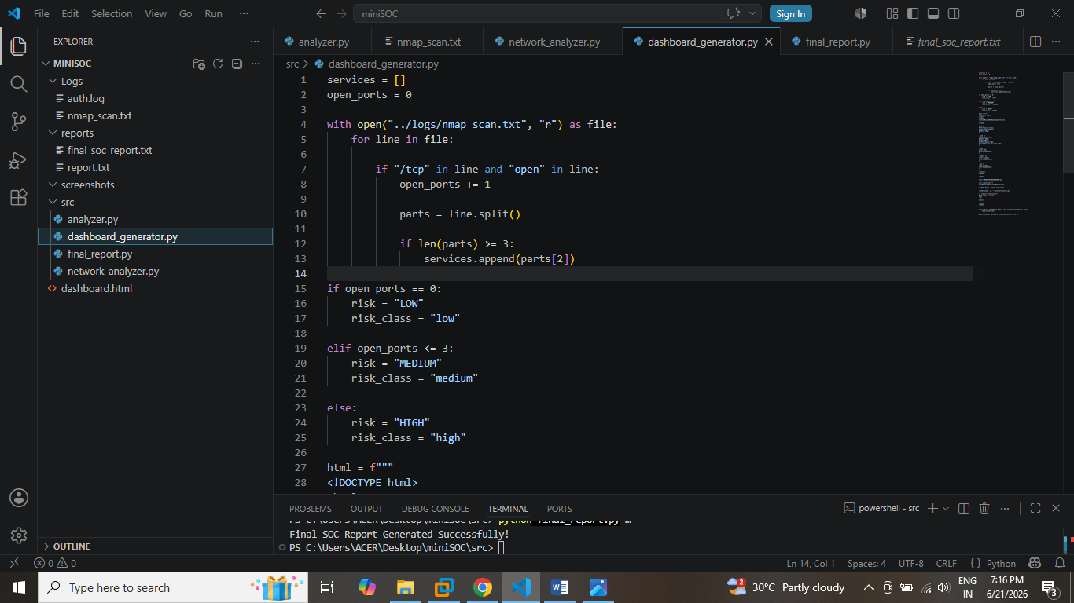

4. Final SOC Report Module
The final report combines:
- Authentication Analysis
- Threat Detection
- Network Scan Results
The report is stored in final_soc_report.txt.
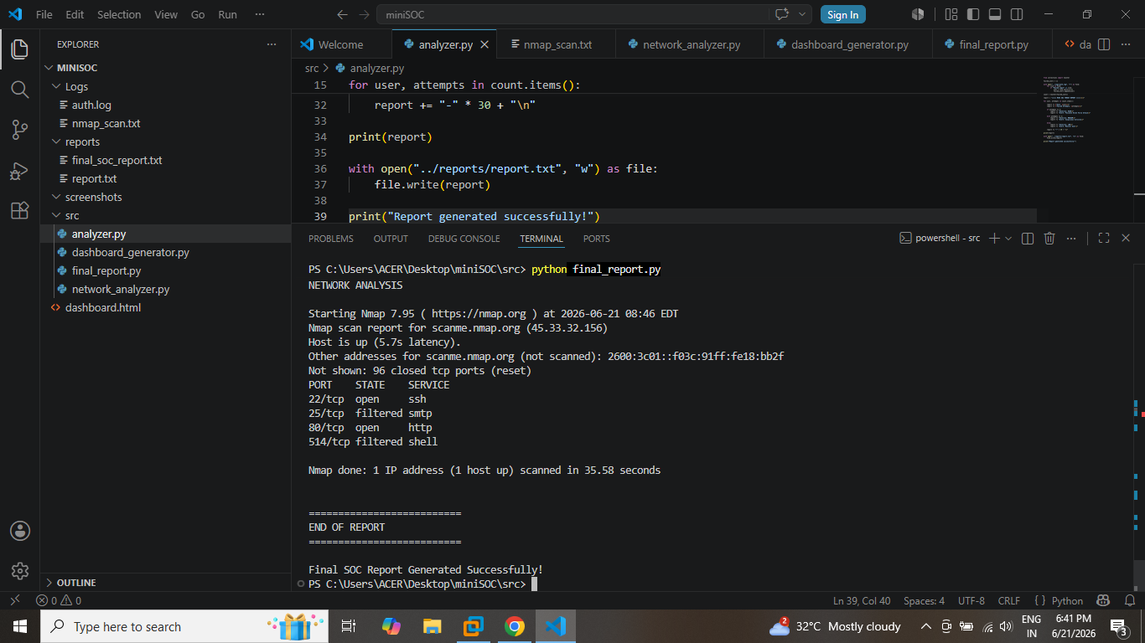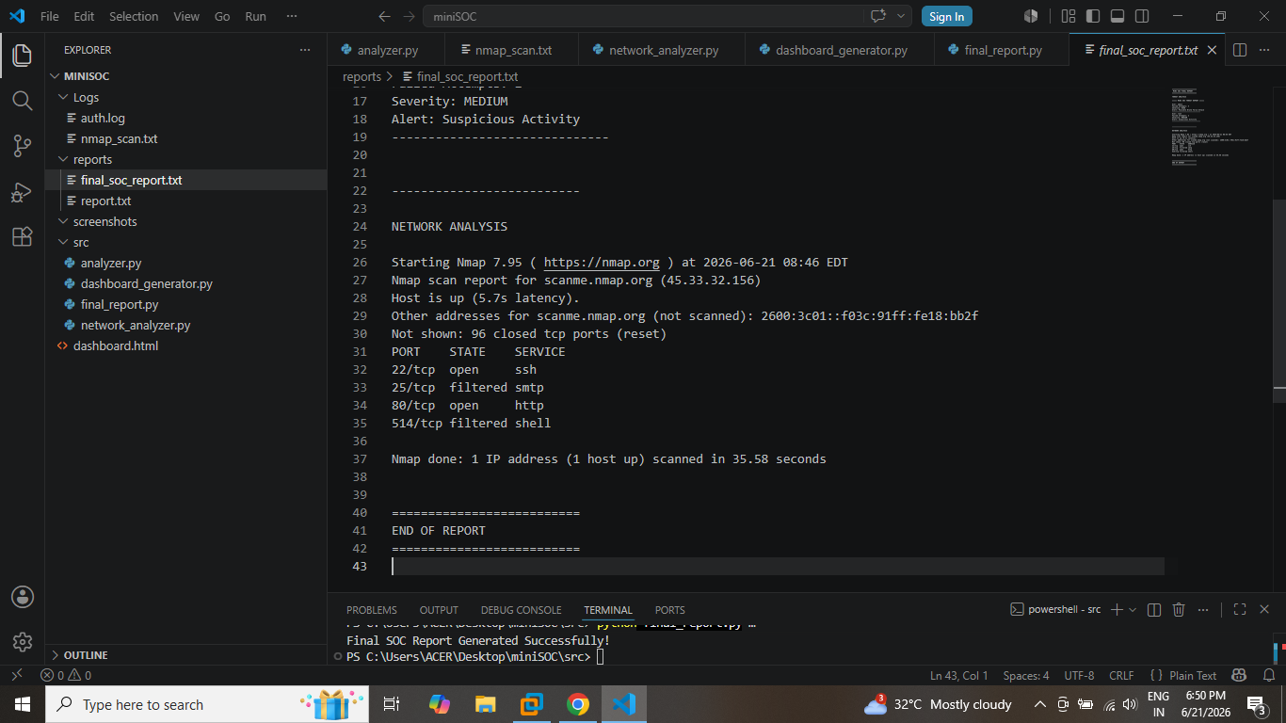

RESULTS AND FINDINGS
The project successfully detected suspicious login activities from authentication logs.
Findings:
- Admin account generated a HIGH severity alert.
- Root account generated a MEDIUM severity alert.
- Network scan identified SSH and HTTP services.
- Risk level was calculated as MEDIUM.
- Dashboard successfully displayed security information.
- Final SOC report was generated successfully.

CHALLENGES FACED
During project development, the following challenges were encountered:
- Configuring Nmap in Kali Linux
- Parsing log files correctly
- Generating dynamic reports
- Integrating multiple Python modules
- Displaying results in HTML dashboard
- Managing file paths between folders
These challenges were solved through testing and debugging.

CONCLUSION
The Mini SOC Dashboard project successfully demonstrates basic Security Operations Center functionality. The system analyzes authentication logs, identifies suspicious login attempts, performs network scanning, generates security reports, and displays information through a dashboard.
The project provides practical understanding of cybersecurity monitoring and cyber defence concepts. It can be further enhanced by integrating real-time monitoring, databases, and advanced threat detection techniques.

REFERENCES
- Nmap Official Documentation – https://nmap.org
- Python Official Documentation – https://www.python.org
- Kali Linux Documentation – https://www.kali.org
- Cybersecurity Fundamentals Study Materials
- Academy of Tech Masters Internship Resources

APPENDICES

Appendix A – Tools Used
- Python
- Nmap
- Visual Studio Code
- Kali Linux
- HTML
- Chrome Browser

Appendix B – Project Files
- analyzer.py
- network_analyzer.py
- dashboard_generator.py
- final_report.py
- auth.log
- nmap_scan.txt
- report.txt
- final_soc_report.txt
- dashboard.html

Appendix C – Project Screenshots
- Project Folder Structure
- Authentication Log
- Threat Report
- Nmap Scan Result
- Network Analyzer Output
- Dashboard Generator Code
- Dashboard Output
- Final SOC Report
- Final Report Generation

